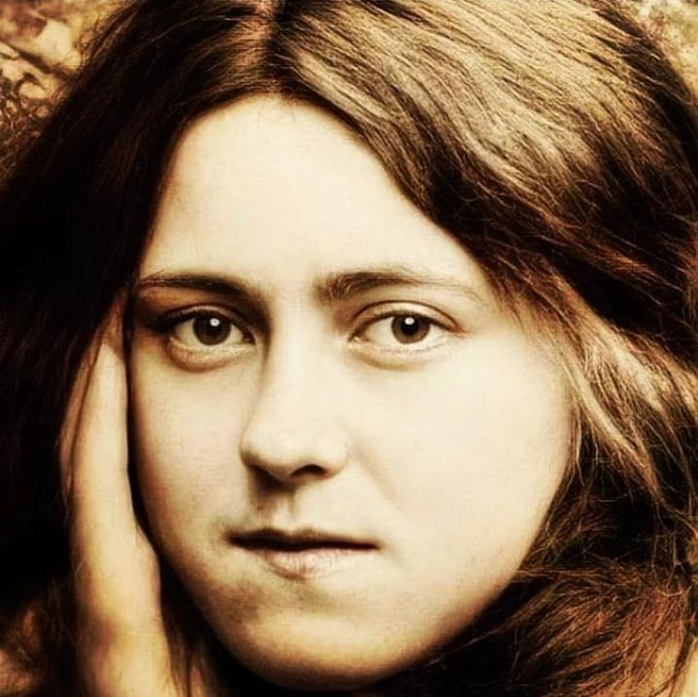
The Holy Face of Jesus Newsletter

Issue 1
  - October 1st, 2024

A faint impress… 'of Thy sweet, humble, patient Face'

"Oh, leave on me some impress faint,
Of Thy sweet, humble, patient Face and soon I shall become a saint and draw men to Thy saving grace…”
Welcome to the inaugural Holy Face of Jesus newsletter on behalf of Human Life International Ireland launched this feast day of that great patroness of the Holy Face, St Therese of the Child Jesus and the Holy Face. Therese was canonised May 17th 1925, 28 years after her death, and declared the 33rd Doctor of The Church by Pope St. John Paul II in 1997. Some of the most beautiful poetry and prayers to the Holy Face of Jesus were composed by the ‘Little Flower.’
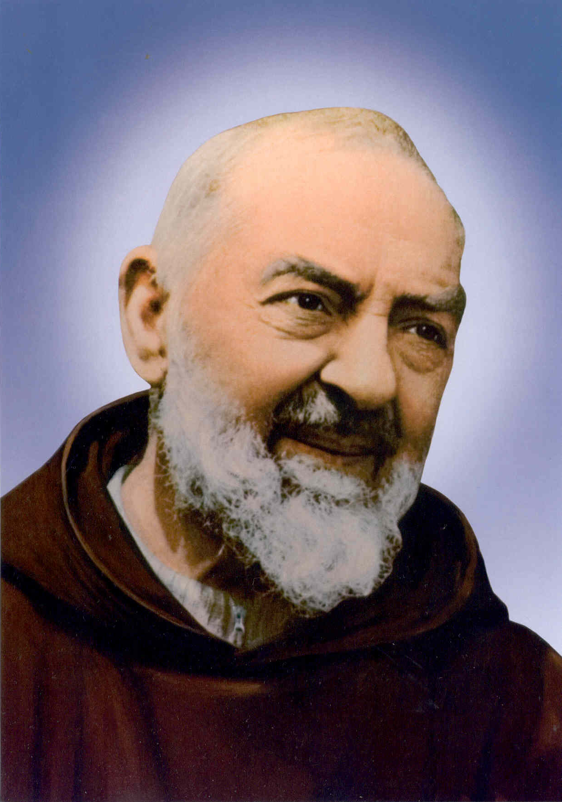
A cloistered Carmelite nun, she is best known for her ‘Little Way,’ which calls us to perform our duties with faithful obedience, sacrifice and patience, and to be generous and loving to those around us, especially those we find trying. However, there is much more to Therese’s spirituality, and through the rediscovery of the Holy Face devotion, the world is waking up to another side of St. Thérèse’s intimacy with Jesus. (New video coming soon: ‘St Therese & the Holy Face, a love story for our times.’
Therese was not alone in her love of the Holy Face, other great saints and popes including Popes Pius IX, XI, XII and Leo XIII encouraged devotion to the Holy Face of Jesus while Popes John-Paul II and Benedict XI progressed central figures in the Holy Face story such as Ven. Leo Dupont and Bl. Maria Pierina on the path to sainthood. All of these sought amidst great joy and suffering, through contemplation and the eyes of faith, the bridegroom of our hearts and Church; Jesus Christ, envying the angels who could behold Him Face to Face. Indeed the great Saint Padre Pio, whose Feast day we celebrated last Monday week, made a habit of distributing medals of The Holy Face, referring to them as “Your ticket to Heaven!”
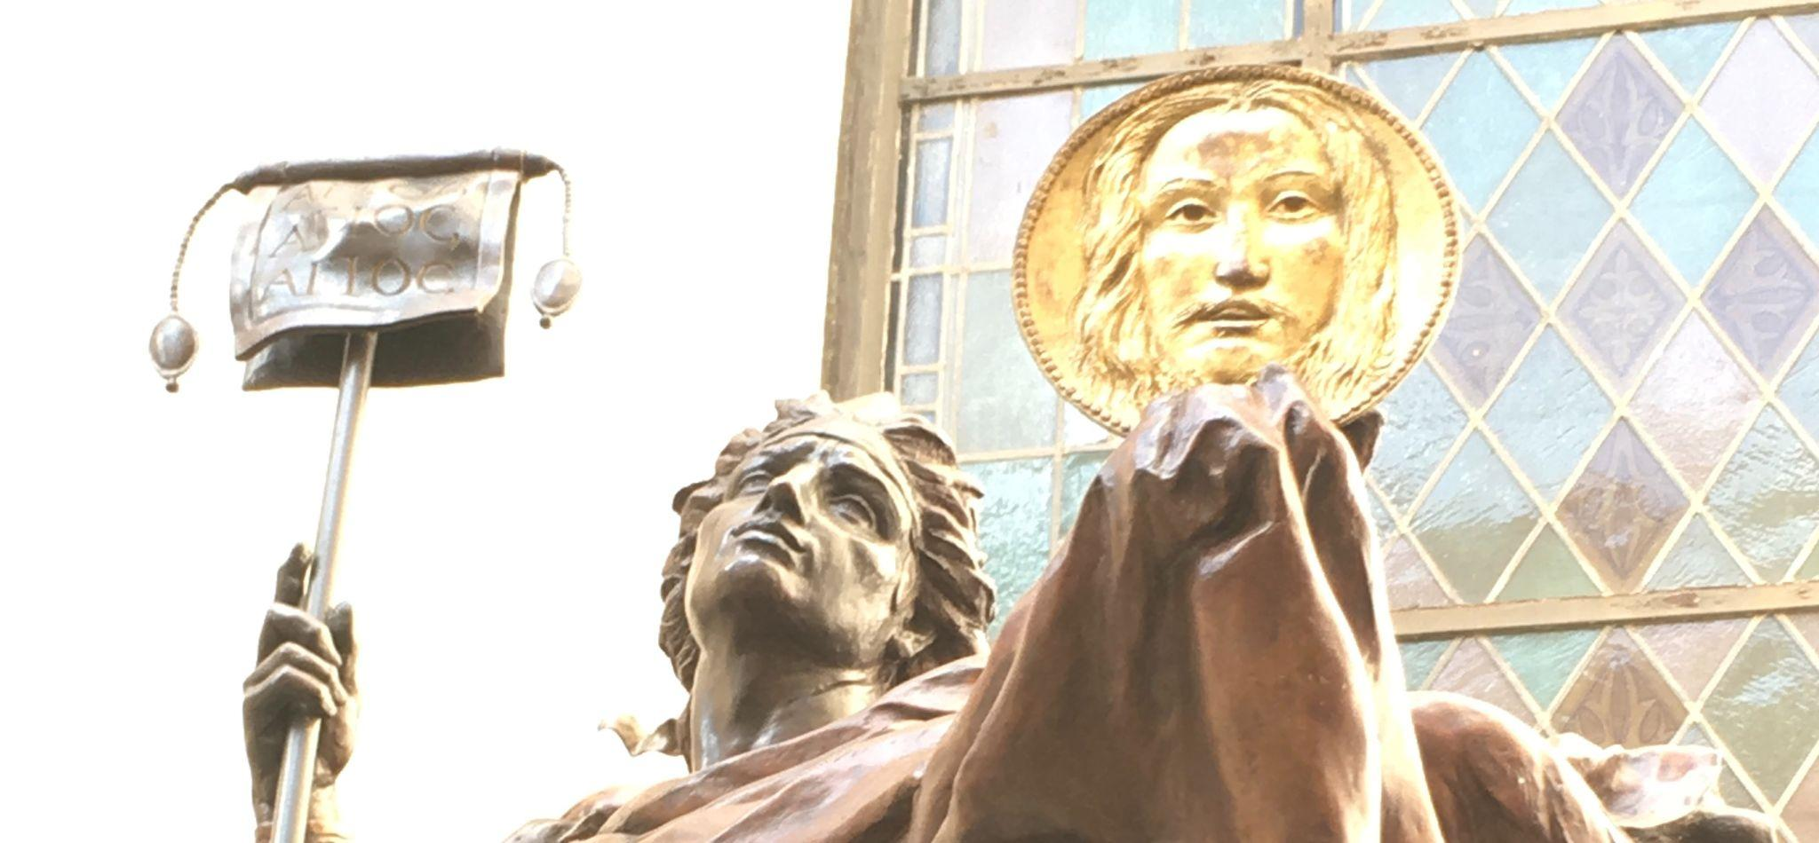
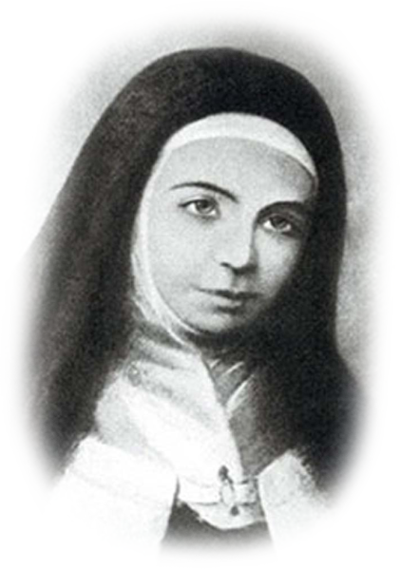
On Sunday 29th last, we celebrated the great feast of the archangels Michael, Gabriel and Raphael. St Michael the Archangel, is the primary patron of devotion to the Holy Face. This is reflected in many ancient works of art in churches where St. Michael or the Holy Angels are portrayed holding the Veil of the Face of Christ as their standard (right). This confirms how devotion to Jesus’ Face is repairing mankind’s broken relationship with God which happens consciously or through forgetfulness from our breaking of the first three commandments. This is manifested in our world by the evil of unbelief and idolatry, blasphemy and disrespect for all things sacred, indifference and outright sacrilege of the most Blessed Sacrament and all the downstream consequences in the breaking of the other commandments literally or in the spirit of them. This ‘Work of Reparation’ honouring Jesus’ Holy Face and His Name – which is the concrete sign of God’s existence and our relationship with Him – has been given the protection and help of the Holy Angels.

But it was Therese’s forerunner, the mystic, Sr. Marie de St. Pierre (right), (Sr Marie of St Peter), a French Discalced Carmelite nun to whom Our Lord gave the original revelations of the Devotion to His Holy Face. She wrote on November 18, 1843: “One day during prayer, our Lord warned me in advance about the fury of Satan against the holy devotion [to the Holy Face of Jesus], but He also consoled me, saying: ‘I give you My Name to be your light in the darkness and your strength in battle. Satan will do all in his power to crush this Work at its roots.
“But I assure you that the Holy Name of God will triumph, and it will be the Holy Angels who will gain the victory in the conflict.”
We would do well, therefore, to imitate Sr Marie, St Therese, St Pio and St. Michael, Prince of the Heavenly Hosts, who humbly chose as his weapons, to adore the Holy Face and invoke the Holy Name of God!

Prayer: Saints Therese, Pio and Saint Michael the Archangel, who was first to tread pride under foot, intercede for this work of repairing for our turning from the Face of God and for its spread to every parish worldwide. Amen.
Call to Action: HLI Ireland aims to get the Holy Face of Jesus into every parish internationally.
Spiritually: Become a HLI ally and missionary of the Holy Face apostolate to the world. Become familiar through books and talks. Pray the prayers for your priests to know the Holy Face. Embed the prayers in your parish by praying them all in one or one prayer daily divided over five days. Organise events: video showings, book clubs, prayer meetings onsite and online. Contact us at info@theholyface.com and let us know if we can help.
Call to Action: HLI Ireland aims to get the Holy Face of Jesus into every parish internationally.
For an overview of the devotion go to our website right: | www.theholyface.com
History & Promises of the Holy Face devotion: >>> | Click History & Promises
Live international Holy Face prayers weekly:  Click right to order medals or an array of materials in our prayer packs  Donate /  Click right to pay by card / Paypal  or scan your phone’s QR reader………right… | Sundays / holy days at 6pm &  Tuesdays at 3.30pm Irish time / GMT  www.facebook.com/theholyface & www.youtube.com/theholyface  Medals  Prayerpacks  Click Donate  

Human Life International (lreland)
For an Ireland where God is First, Life is Sacred and the Family is Cherished
Reg. Charity No.: 20029814 CHY11138 20029814

Human Life International
| The Guadalupe Centre,
Ard Mhuire,
Main Street,
Knock,
Co.Mayo Ireland
Unsubscribe {recipient's email}

